# **LAB DAY-1**

**EXERCISE-1:**

Program(**Addition):**

num1=as.integer(readline(prompt = "Enter the num 1:"))

num2 =as.integer(readline(prompt = "Enter a number2:"))

sum=num1+num2

print((paste("sum:",sum)))

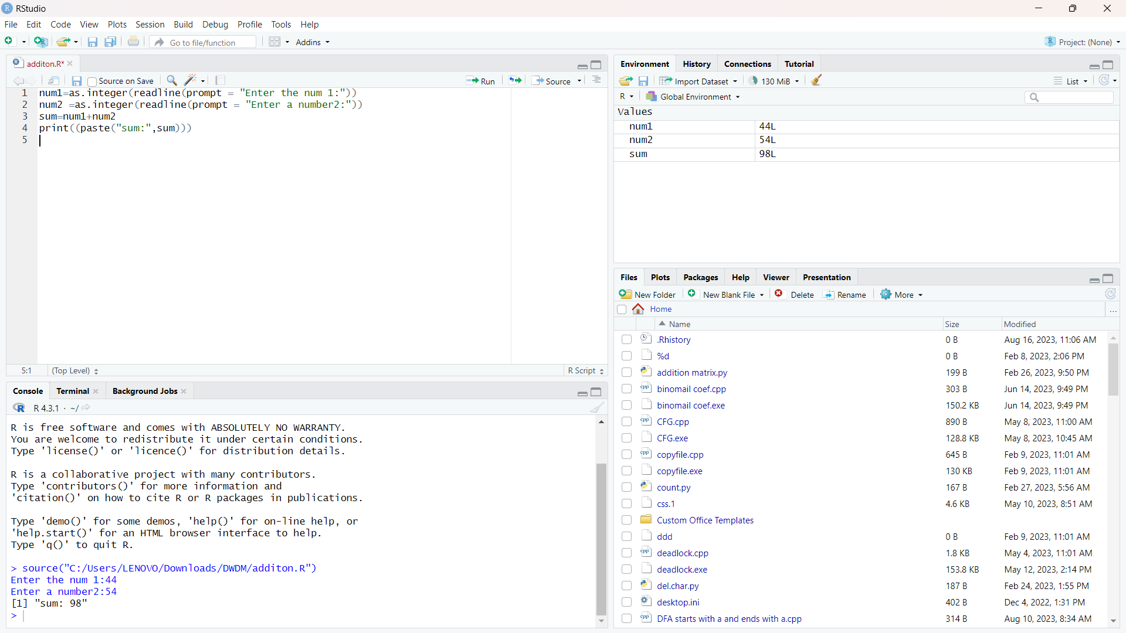

**EXCERISE 2:**

Program(Mean):

height <-c(150,174, 138, 186, 128, 136, 171, 163, 152, 131) result.mean <-mean(height)

print(result.mean)

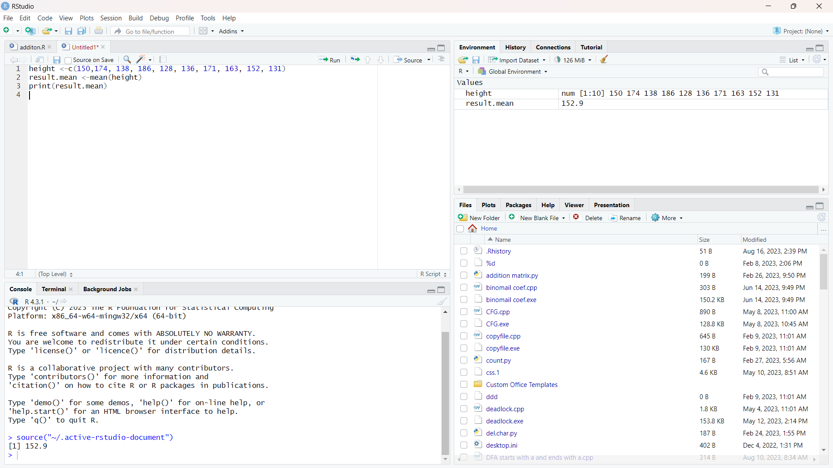

**EXERCISE 3:**

Program(BarPlot):

temperatures <- c(20, 22, 25, 29, 23, 27, 28)

result <- barplot(temperatures,

main = "Maximum Temperatures in a Week”

xlab = "Degree Celsius",

ylab = "Day",

names.arg = c("Sun", "Mon", "Tue", "Wed", "Thu", "Fri", "Sat"),

col = "blue",

)

print(result)

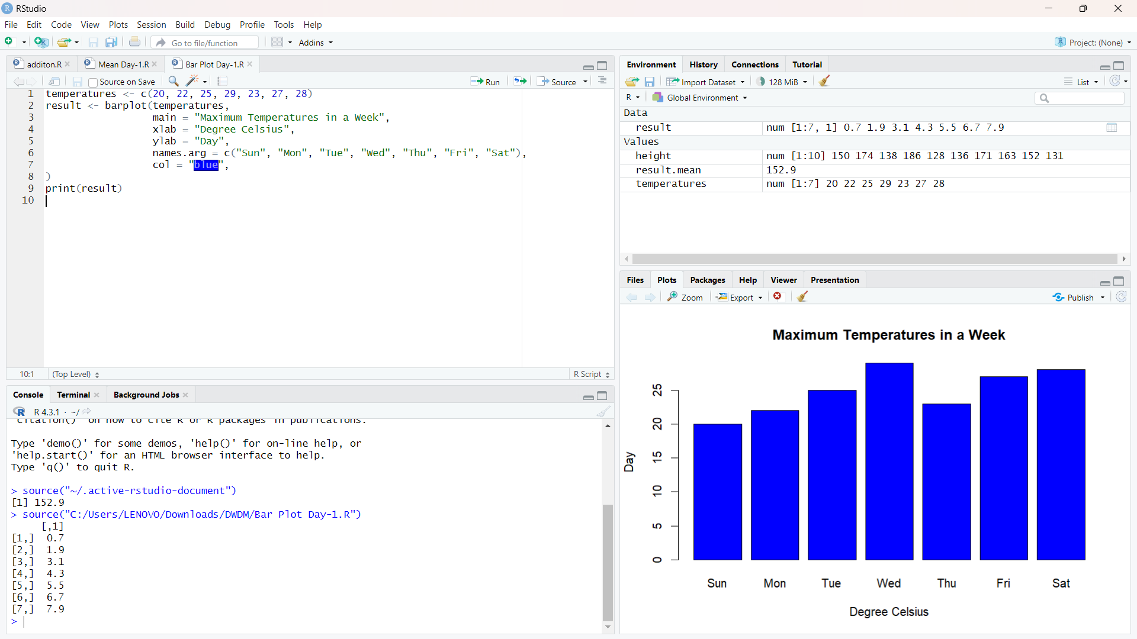

**EXERCISE 4:**

Program(Box Plot):

b <- c(10,12,13,14,17,19,20,30,50,70,90,100)

print(boxplot(b,col="green"))

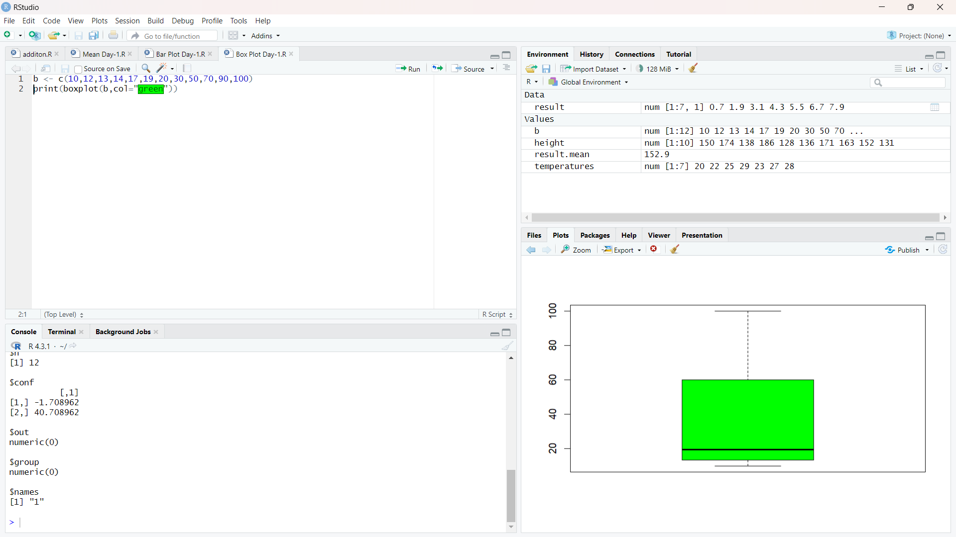

**EXERCISE 5:**

Program(Decision tree):

library(rpart)

library(rpart.plot)

data=read.csv("C:\\Users\\arunk\\OneDrive\\Desktop\\DWDM\\Gender.csv")

tree <- rpart(Height ~ Gender+Weight,data)

a <- data.frame(Gender=c("Male"),Weight=c(85))

result <- predict(tree,a)

print(result)

rpart.plot(tree)

tree1 <- rpart(Gender~ Height+Weight,data)

a <- data.frame(Height=c(170),Weight=c(85))

result <- predict(tree,a)

print(result)

rpart.plot(tree1)